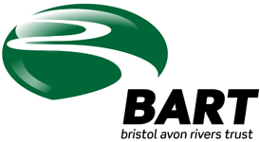
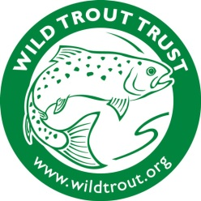

Improving the Wellow Brook
The Environment Agency has provided a small amount of funding to the Bristol Avon Rivers Trust & Wild Trout Trust to improve our local river, the Wellow Brook. The improvements we’d like to make are to increase habitat for trout and to help communities become more involved with the river.
Get involved with this great local project
We will be undertaking vegetation clearance along the river so that the river can be seen better, and making a series of “faggots” to go in the river to provide shelter for fish. No experience necessary, it’s all very simple and we shall show you what to do, and you can do as much or as little as you like.

- It’s Fun
- Meet like-minded people
- Get out in the fresh air
- It’s free to be involved!

When?
The dates are not confirmed yet but are likely to be starting Monday 26th January 2015. The project will be for 2 weeks and you can join us for as much or as little as you like.

How to get involved
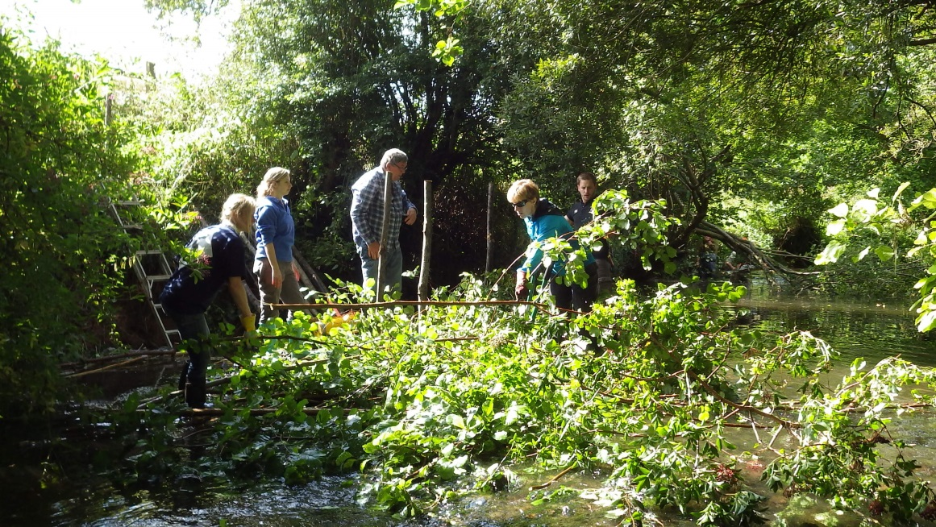
If you’d like to be involved please call Ian Mock on 01179 314160, mobile 07411 488084 or email ian@bristolavonriverstrust.org

