Newsletter July 2013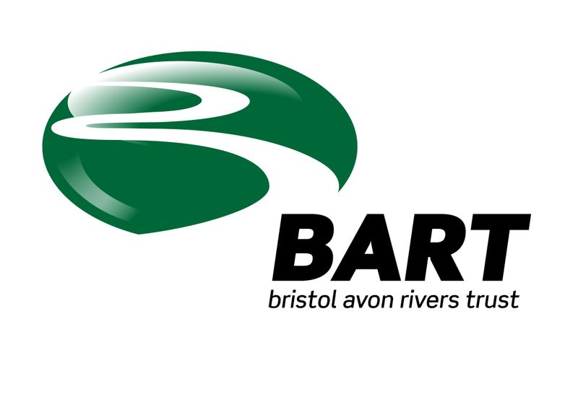

This update follows quickly on the tail of the June one as we have been very busy and have some good news to share. If you have been following the website you may know most of this but hopefully the newsletter will reach a few more river lovers with each issue as it is shared amongst friends and colleagues.
Project Work.
BY BROOK
We are delighted to be able to say out loud that we have been given the go ahead for this project! A lot of hours of preparatory work by both BART and EA staff have helped us reach this stage so a big thank you to all concerned. I have inserted a copy of the text for the press release which will be issued and which we hope will merit some space in our local papers.
Information release for the By Brook Project.

Bristol Avon Rivers Trust (BART) is delighted to announce that they have been chosen by the Environment Agency to lead a Partnership Project on the By Brook. The project comes early in the second year of BART’s development and is a great opportunity to engage with local landowners, farmers, community groups and sporting organisations along the river to deliver much needed environmental improvements to the brook and its tributaries.

BART is a community-led organisation, which aims to deliver education, land and river based management advice and practical river restoration work across the Bristol Avon Catchment. We pride ourselves on getting our feet wet and our hands dirty and on getting things done. We do this by bringing together individual people, interest groups and community organisations with common interests and problems. BART helps to realise these as achievable projects by adding their experience, practical science and by using its volunteer support. Where necessary and possible, BART works in partnership with other organisations and in this particular project would expect to work with the Friends of the By Brook Valley, Avon Wildlife Trust, Wiltshire Wildlife Trust, Buglife and the Environment Agency, among others.

Initial funding for the By Brook project amounts to £140K, over the first year and is a vote of confidence in BART’s ability to deliver. The work will involve a number of strands with an emphasis on improving the Brook’s Water Framework Directive classification from “Poor” to “Good” over time.

The initial phase will involve working with local stakeholders to determine quick wins that can be delivered in 2013-14 and carrying out survey work, essential to determine numbers and types of invertebrates and fish present in the Brook. Feasibility work for fish passes will be carried out on a number of weirs, which would help improve the ability of fish to move between spawning, nursery and feeding grounds within the Brook and to colonise areas currently lacking in variety and numbers.

An experienced Farm Liaison Officer will work with farmers within the catchment to help them develop “catchment friendly” methods of farming that will greatly help the By Brook to recover some of its former ecological diversity.

An essential part of this work will be a survey of native white clawed crayfish as these scarce creatures are present within the Brook and its side streams, despite the incursions of an invasive species , the signal crayfish. It is hoped that successful feasibility studies and completion of a number of habitat improvements will lead to further work on the Brook in future years.

If you are interested in following the progress of this project, you can do so on BART’s website at www.bristolavonriverstrust and if you feel you’d like to contribute in any way to this or any future projects we would be delighted to hear from you.

The picture below is just one of the areas we will would hope to improve by persuading the landowner to allow us to build a buffer strip alongside the river as the present margin is just too small. Considerable soil loss occurs whenever this spatey Brook floods which is not good for the landowner or the river as the sediment chokes gravels and plantlife.

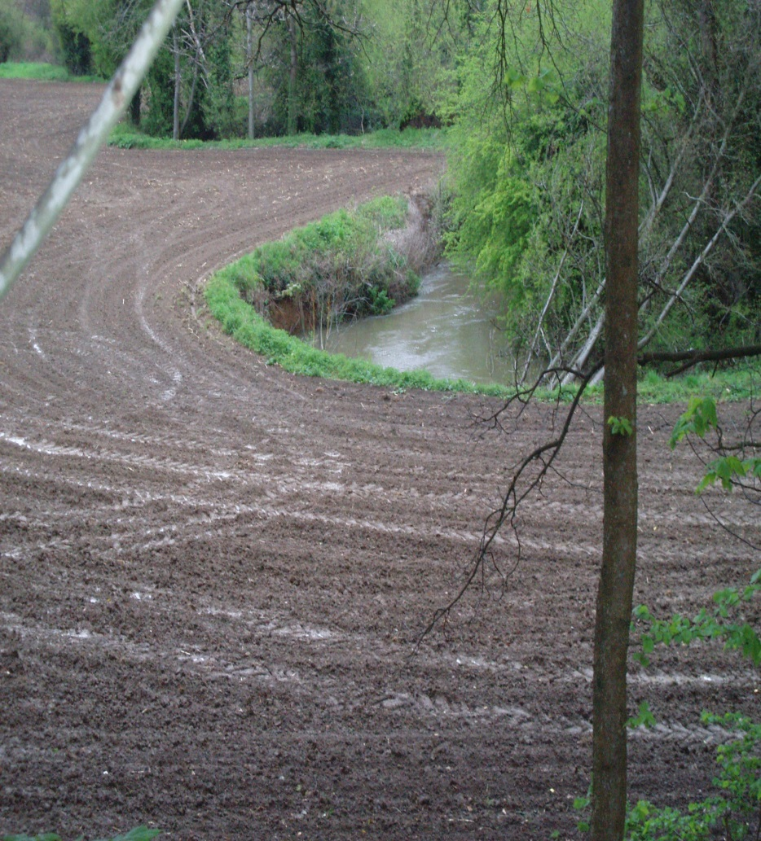
PES Project – Little Avon at Tortworth.
This project has completed its second main stage and is likely to be completed in August this year. It has been an exciting exploration of possibilities and practicalities and the final report should be an interesting indicator for the future in similar projects. I have attached the initial executive summary as this best describes the projects purpose. Since the project commenced the team have been joined by Rob McInnes a world renowned wetlands expert.
EXECUTIVE SUMMARY
This work forms part of the DEFRA Payments for Ecosystem Services (PES) research project, which aims to guide and learn from the development of real life PES agreements, through their development and implementation. A team of knowledge providers, comprising members of Bath Spa University’s Science Department, the environmental consultancy Engain and RM Wetlands have been brought together by the Bristol Avon Rivers Trust, which is acting as an intermediary, to facilitate the development of a PES agreement between Wessex Water and the Tortworth Estate.
The PES agreement centres on the development and on-going management of an integrated constructed wetland (ICW), principally designed to remove phosphorus from sewage effluent discharging from Cromhall Sewage Treatment Works.
The aims of this project are:
• to facilitate the development of a win-win PES agreement between Wessex Water and
the Tortworth Estate that enables a cost-effective and environmentally sustainable solution to the issue of P loading from Cromhall STW to be implemented and;
• to evaluate the stepped approach to setting up PES agreements given in the DEFRA guidance
The project team will follow the steps laid out in Phase 2 of the DEFRA PES guidance document, in the development of this agreement and will report to DEFRA on its approach and findings.
Smaller ongoing projects
Bart is involved in a number of small projects on the Bristol Avon near Malmesbury and researching the possibilities of a more sizeable project below the town. These are in conjunction with local landowners and angling associations.

An environment agency team of volunteers is helping to carry out some river improvements on a stretch of the upper Bristol Avon above Kingsmead Mill on the weekend of 17th – 18th September. We hope to be able to build some fry refuges along the gravel shallows and perhaps to add some wood riffles to improve the habitat for the wild brown trout and grayling populations in the area. The event is already turning into quite a team building effort setting up the days activities and achieving consents.

Engagement

BART supported the Bristol Festival of Nature having a stand in the WildWaters tent alongside the EA stand. The photos of fish and in particular the shots of barbel spawning drew a lot of interest and it was good to be able to share our interest for the river with the great Bristol public. A number of people expressed interest in volunteering and we hope to see more of them in the Summer.
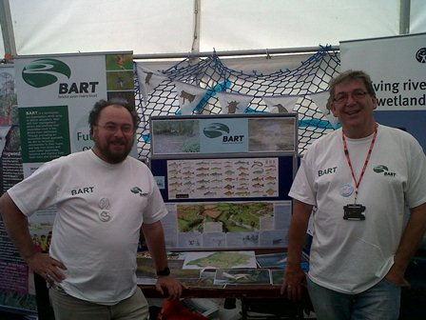

BART will have a stand at the Horizon House “market” as part of the EA volunteering month on 10th July. We hope to have better weather for any volunteers than we did for our last outing with EA staff!
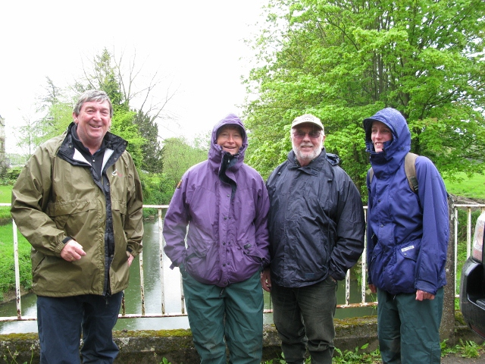

BART were invited to help Avon Tributaries Angling Association on their recent weekend to raise interest on their lovely waters on the Somerset Frome. The club had potential new members and juniors out in numbers for the weekend which was good to see. A roving “match” to see who could catch the most species was won by Dr Julian Greaves of BART who caught six species including a pike. I caught the biggest fish of the weekend with a chub of nearly four pounds which was in fine condition. The river is not short of minnows and there are good numbers of small dace and chub.
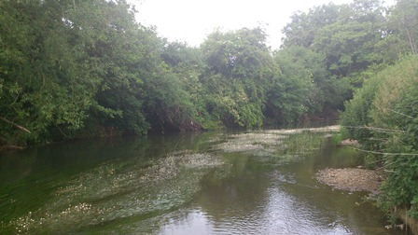
BART is holding a number of events this Summer and Autumn where Dr Mark Everard will speak about the fish of the Bristol Avon and their habitat requirements. The first of these is an event for Charfield Angling Association who have also invited the Berkeley Estate Fishing Syndicate to attend.
A walk over of the Riverside Angling Associations waters has provided the club with ideas for river improvements and BART is helping shape these into viable projects. These improvements only need a small amount of cash but can make a significant impact on the riverside environment. Plans for a school visit and river walk are also in train.

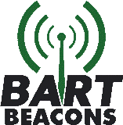 BART Beacons are the way we are establishing a community of
interest groups across the catchment who feedback news from across the catchment like old fashioned radio masts. They will be the “eyes and ears” of BART identifying problems or opportunities on their local stretch of river or stream. BART will share this information with other Beacons and look for opportunities to bring these together on logical projects to improve the health of the river. Local knowledge and interest is all you need to become
a beacon; whether you are an individual who has something to share or a community or interest
group we would love to hear from you.

We have established a number of beacons and are going to use the By Brook press release and a mailing campaign to extend our reach as quickly as we can across the catchment. Beacons are not necessarily volunteers but are independent partners with a mutual interest in sharing news across the catchment. We have a number of volunteers now too and we will be getting them involved wherever we can.

Please take a look at our website – www.bristolavonriverstrust.org and follow us on Facebook and share this with any friends who have an interest in the river.

Feedback or questions are welcome – just give me a call on 07411488084. Ian

