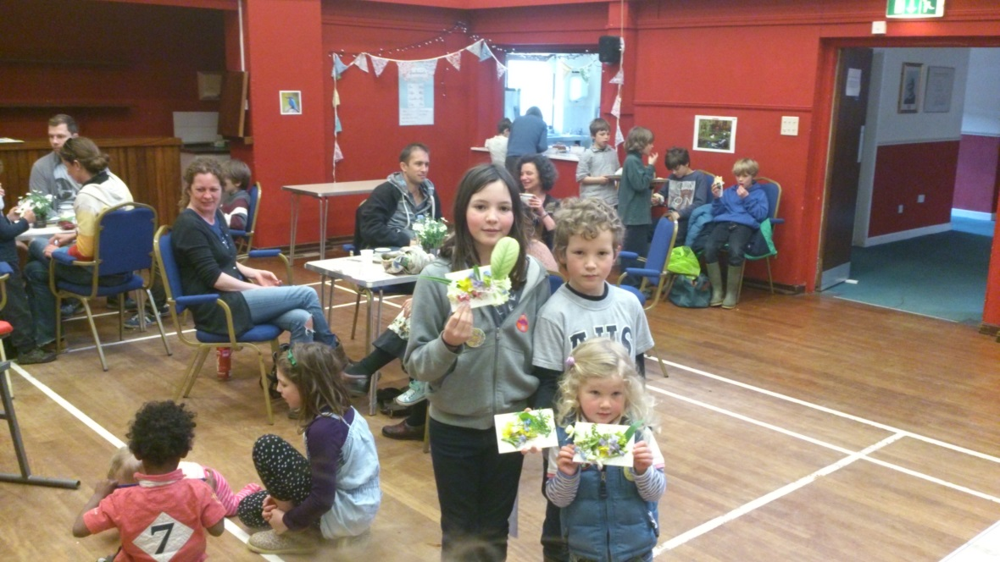
Above: Children with their flower collections from their river walk
The sunny weather last Saturday brought out a number of active kids and their parents to BART’s very first engagement event. The ‘Love Your River Kids Day’ attracted over 30 children with their parents to participate in fun river-related activities. BART along with the Environment Agency, the Avon Invasive Weed Forum, the Wild Trout Trust, and Wiltshire Wildlife Trust had stands with fun and interactive games, including creating your own farm model, badge making, Easter bunny hunt, and trays of river bugs to look at and identify. The most popular of all, however, was the emriver model. The emriver model provides a way of simulating normal riverine processes such as sediment transport and deposition processes. It also provides a way of visualising the impacts of different river and riparian issues such as the impact of weirs, and the effect of dredging. The model is both educational and fun and certainly kept most of the children captivated for a number of hours!
The day was a success and lead to an increased awareness of BART as an organisation and the work we do; whilst also improving children’s understanding and respect for the river environment. One family enjoyed themselves so much that they tweeted about it once they got back which led to 2 additional families coming down to the event.
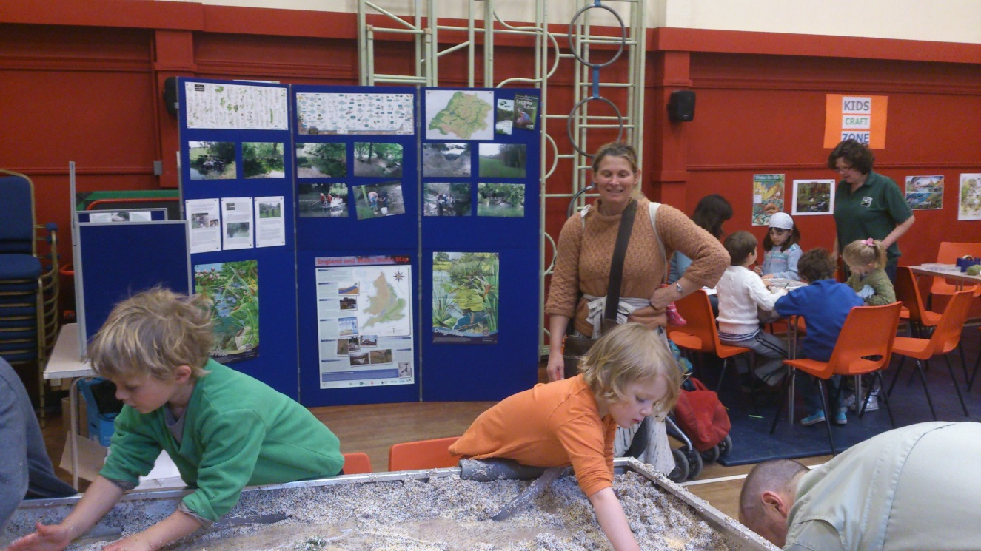
Above: Children enjoying the river emmodel

