Weight of evidence of Eutrophication
Eutrophication: “the enrichment of water by nutrients, stimulating an array of symptomatic changes including increased production of algae and/or higher plants, which can adversely affect the diversity of the biological system, the quality of the water and the uses to which the water may be put”.
The assessment of eutrophication has for many years followed the Weight of Evidence (WoE) principles. The reason for taking this WoE approach is that ecosystems respond and behave in different ways to pressures, as well as often exhibiting natural inherent variability, it is therefore more appropriate to look at a range of parameters.
Because WFD classification works on a ”one-out-all-out” principle at the quality element level, if supporting elements such as nutrients “fail” then a water body is classed as moderate status, regardless of biological compliance. However, through our WoE approach we assess the evidence of not only the nutrients but also their impacts, using the plant/algal quality elements, and the certainty that these are or are not less than good. We also account for wider WoE of eutrophication, where appropriate and available, to increase certainty. This assessment, of certainty of eutrophication, does not affect the classification results but helps to identify problem areas and informs decisions on subsequent actions, providing a link between classification, standards and measures.
It is this wider weight of evidence of eutrophication that we are asking you to let us know about. The following are examples of the type of evidence we wish to gather.

Evidence of excessive plant or algal growth. Anecdotal evidence of excessive plant or nuisance algal growth - this can be survey information, photographs, letters or confirmed records:
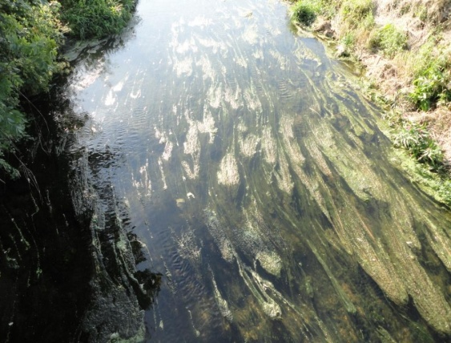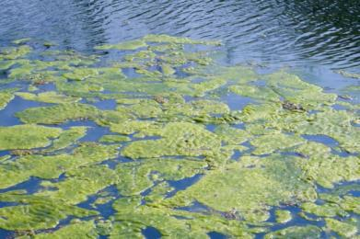

Evidence of impacts on recreational use . Anecdotal evidence of impacts on recreational use as a result of eutrophication, cancellation of fishing matches or water sports activities and regattas:
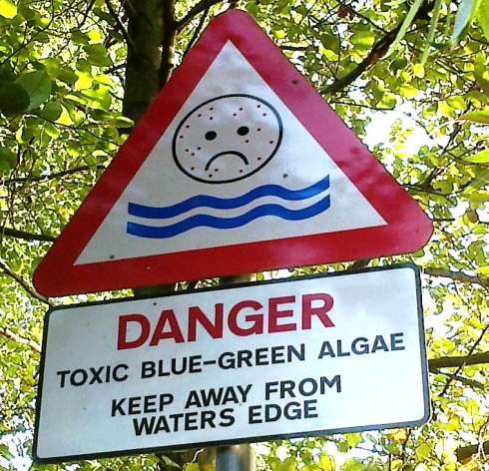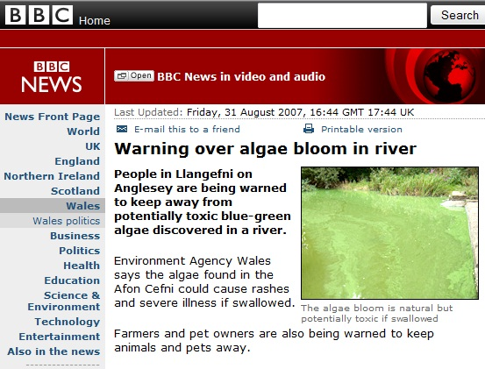

Aesthetic effects. Evidence of foam, odours or scums resulting from eutrophication:
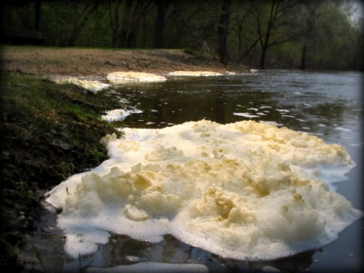

Anecdotal evidence of impacts to invertebrates or fish. Evidence of fish kills or invertebrate deaths due to eutrophication - as a result of deoxygenation or extremes of pH
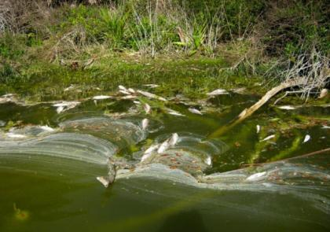

Please provide the following details for any record:
Reporters name/organisiation:
Your contact details: (For further information)
Location: River Name and Site (National Grid Reference)
Date: When did this occur and for approximately how long
Type of record: Survey/Photographs/Anecdotal/Other
Extent of impact: How much of the river was impacted – the whole channel, the margins, how many kilometres/metres, does this happen every year or only infrequently?

