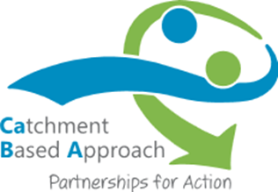

What is the Catchment Based Approach?
The Bristol Avon Catchment Group (BACG) is one of the original 15 pilot groups (non-EA led) set up with support from Defra to test the Catchment Based Approach (CaBA), a framework that was nationally adopted on the 3 June 2013. The principle is that the whole catchment is considered holistically in an integrated way rather than by treating rivers, policies and actions in isolation. The CaBA aims to bridge the gap in effective planning between higher-level river basin planning (as required under the Water Framework Directive) and local action.
The BACG has moved forward from its pilot phase to project implementation and has published the Bristol Avon Catchment Plan (see Appendix 1). Its overall aim is to provide a framework to deliver healthy rivers with high quality local environments for people and wildlife with an emphasis on achieving “good water quality status” for all rivers in the catchment.
At a similar time to the establishment of the Catchment Pilot, Local Nature Partnerships were being formed, again with the aspiration to deliver holistic local management and delivery for the natural environment. The Bristol Avon catchment incorporates the North Somerset and South Gloucestershire Streams and covers a large geographical area. This area covers two different Local Nature Partnerships- West of England and Wiltshire & Swindon.
It is intended that the Bristol Avon Catchment Group becomes the sole ‘expert’ water group for both Local Nature Partnerships and aligns with Local Authority plans and policies to deliver joined up and efficient water management across the catchment.
The Bristol Avon Catchment Group currently consists of the Avon & Frome Partnership, Avon Wildlife Trust, Bath & North East Somerset Council, Bristol Avon Rivers Trust, Bristol City Council, Environment Agency, FWAG South West, Wessex Water & Wiltshire Council
Aims of the Bristol Avon Catchment Group
• To deliver an action plan for the Bristol Avon catchment
• To collaboratively identify strategies and opportunities across the catchment to deliver water quality and quantity (flooding) improvements to achieve the requirements of the Water Framework Directive, Biodiversity 2020 and facilitate sustainable development across the different political boundaries
• To develop synergistic and complimentary local government, Local Nature Partnership and private business development / action plans to facilitate the achievement of these aims which support an overall Bristol Avon Catchment Plan
• To provide a mandate to partnerships and delivery bodies.

