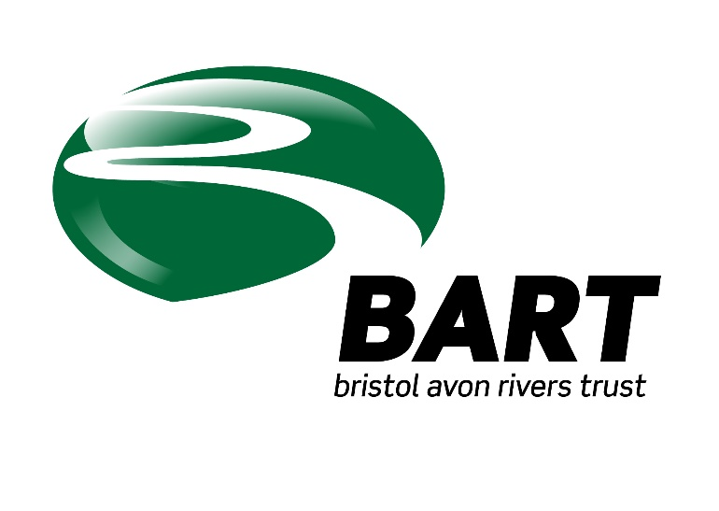
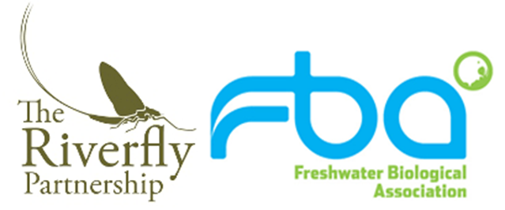

BRISTOL AVON FLY MONITORING INITIATIVE – BART BECOMES A RIVERFLY HUB FOR THE CATCHMENT

Background

The Bristol Avon Rivers Trust (BART) has spotted an opportunity to expand volunteering and engaging people actively with their local river through working with the Riverfly Partnership. Volunteering, particularly in the outdoors, is known to improve health and wellbeing for participants, whilst Riverfly Monitoring provides the opportunity to make a useful and ongoing contribution to river conservation. This activity is made further attractive to participants because they are able to engage and work with likeminded individuals.
Riverfly Monitoring also acts as a first line of defence against degradation in water quality and, unfortunately, it is often the first reporter of more serious pollutions because trained volunteers are monitoring regularly. In addition the data collected is useful to the Riverfly Partnership, who launched a national invertebrate database in July 2014, as well as BART, local biological record centres, the Environment Agency and Wildlife Trusts.
BART’s early experience of invertebrate monitoring shows that there is a demand for involvement wherever we have worked, and, that this demand remains unfulfilled because of insufficient training resource. We believe also that follow up activity to support groups and to share information will help maintain the impetus gained from initial training and provide a base for further skills training.

BART have discussed the current situation with Ben Fitch who as well as being one of our team is also the National Riverfly Monitoring Co-ordinator for the Riverfly Partnership. Ben has agreed that having BART operating as a hub across the Bristol Avon Catchment will help both BART and the Riverfly Partnership meet their objectives, saying ‘a BART Riverfly hub will play a key role in the national network by providing training, support and coordination to volunteers across the Bristol Avon catchment. This is an excellent development for Riverfly and for citizen science in the South West.’ The Bart hub may also offer additional areas of involvement to those who take part. We are therefore starting to make plans.
The hub will not replace any existing groups but will welcome them and any individual fly monitors in the catchment to take part in any events we organise – the more the merrier we believe.

What is BART proposing to do?
BART proposes to become a Riverfly Partner Organisation co-ordinating activity across the Bristol Avon Catchment.
BART will initially train two qualified assessors.
BART will provide free training to all its volunteers to provide a flexible monitoring team across the catchment.
BART will seek funds to provide free training for angling and community groups across the catchment within all its projects and initiatives and will raise funds or provide advice to help these groups acquire the equipment they need. Where funding and initiatives are not available BART will provide training, provided a contribution is made to the expenses of running the event as is customary practice for Riverfly initiatives.
BART will share the data collected as agreed with the Riverfly Partnership and with other local stakeholders.
BART will run regular refresher and social events to support the trainees and the aims of the Riverfly Partnership, and, to improve trainees’ knowledge so they can further contribute to improving the health of their local rivers and streams.

Look out for further updates on our website or ask to be included on our Newsletter mailing list where we will include any future events. If you would like to lodge an interest in being involved as a group or an individual please contact me at ian@bristolavonriverstrust.org.

