Bristol Frome – Four Brooks Project

Introduction
The Bristol Frome Four Brooks Project forms a key preparatory component of a wider strategy for the Bristol Frome Catchment, being delivered by the Bristol Avon & North Somerset Streams Catchment Partnership, in collaboration with local community groups. The Catchment Partnership comprises representatives from wildlife groups, water companies, councils and the Environment Agency as well as the Avon & Frome Partnership, Bristol Avon Rivers Trust (BART) and FWAG SW (Farming and Wildlife Advisory Group South West).
The widespread modification and habitat degradation that has accompanied historic industrialisation and continued urbanisation of much of the catchment, together with current agricultural diffuse pollution, provide numerous opportunities for improvements that could re-establish connectivity between stranded fish populations, increase diversity of habitat for the benefit of all wildlife and improve overall catchment functioning to achieve WFD Good Ecological Status.
These long-term goals will be achieved by the Bristol Frome Catchment Initiative by delivering:

- improvements to fish passage to re-establish connectivity between stranded fish populations and migratory species
- improvements to riverine habitat, to mitigate the impacts of river modification and previous habitat degradation
- reduction of chemical and sediment inputs from urban sources to improve water quality and benthic ecological value
- reductions in nutrient and sediment inputs from diffuse agricultural sources to improve water quality and benthic habitat for spawning.

The Four Brooks Project will help to deliver these long-term goals by:
- Working with the farming community to improve water quality issues.
- Engaging with schools and community groups to establish a knowledge and interest in river life and a sense of ownership of the future quality of those waterways near their homes.
- Improving riparian habitat for fish and a variety of other wildlife, particularly in areas heavily modified by man.

A general work stream will run concurrently with this project planning the future stages of the Bristol Frome Catchment Initiative, widening the scope and stakeholders and ensuring the highest possible levels of community feedback and involvement to ensure that plans exist to carry on works once the Four Brooks project has been completed.

Project Delivery
The Catchment Partnership has agreed that the project will be managed by BART with key components being led by FWAG SW, BART, and the Avon & Frome Partnership. Additional supporting contributions are expected from South Gloucestershire Council, Bristol City Council, the Environment Agency, Avon Wildlife Trust, Wild Trout Trust, and Water companies.

Project location.
It is proposed that this project will focus on the headwaters of the Bristol Frome (Figure 1), in particular the Laddon Brook and three of its urban tributaries, the Bradley Brook, Stoke Brook and Folly Brook.

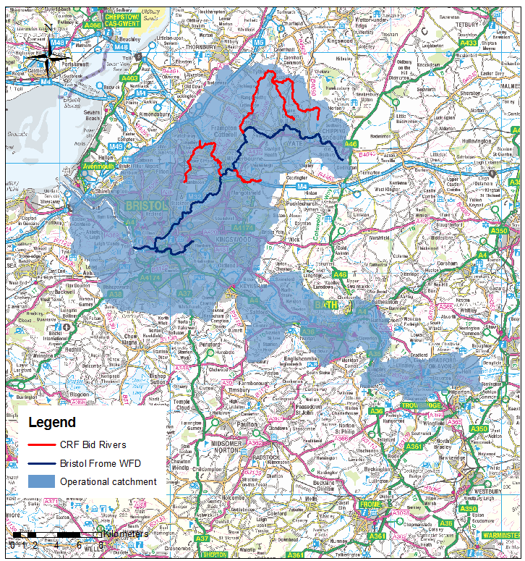
Laddon Brook
Bradley and Stoke Brooks
Folly Brook
Figure 1. Project area, showing Bristol Frome (dark Blue) and the Four Brooks (red) and the Lower Bristol Avon Operational Catchment (shaded area)

Four Brooks Project in detail

The Four Brooks project builds on an advisory report produced by the Wild Trout Trust, and on-going engagement activities by the Avon and Frome Partnership and data provided by the Environment Agency regarding the Bristol Frome Catchment. The locations chosen offer an opportunity both to make a significant start towards impacting on failing elements within the Water Framework Directive and also involving communities in this highly urban area in activities both to enhance their local streams but also to become involved in their future care and maintenance.

Waterbody name | Waterbody ID | 2015 Predicted WFD Status | Failing elements | Risks identified
The Laddon Brook | GB109053027590  GB109053027560 | Moderate | Fish | Diffuse source pollutions. Phosphorous from agriculture. Pesticides.
Folly Brook | GB109053027830 | Good | None
Bradley Brook/Stoke Brook | GB109053027840  GB109053027570 | Moderate | Fish,  Invertebrates,  Phosphorus | Combined source nutrients, Physical or morphological alteration, Morphological pressure, Phosphorous

Project elements

Working with the farming community – led by FWAG SW.
The project aims to begin the process of measurably reducing phosphorous and other nutrient levels, particularly within the Laddon Brook area.

Walkover surveys of the catchment indicate that there is a considerable amount of diffuse pollution from agriculture occurring in the catchment, particularly upstream of Winterbourne Down and in the tributaries of the Bristol Frome. River banks in several areas are heavily poached by cattle, leading to sediment and nutrient contamination. This, together with poor nutrient management and river-channel modifications have resulted in elevated phosphate concentration, eutrophication, and destruction of spawning gravel habitat for fish and invertebrates.
In addition, a number of examples of poor practice were observed, including uncovered manure heaps on concrete yards with direct pathways for farm pollutants to the watercourses. (Figures 2 and 3).

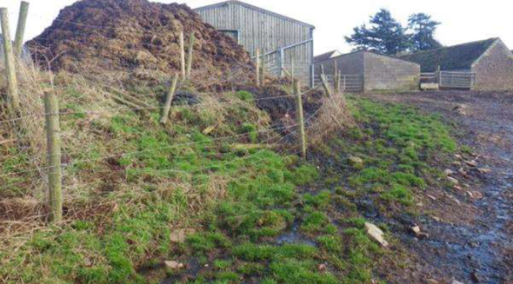
Figure 2.Manure liquor leaches onto the track and downhill towards the drainage network and river
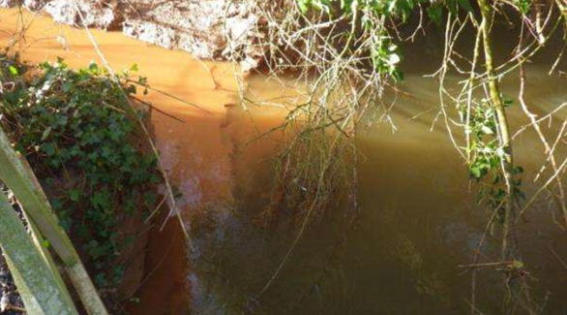
Figure 3. Agricultural drainage ditches introduce fine sediment into the river.

This project will directly tackle these diffuse pollution issues by helping farmers to develop a catchment-sensitive approach. This work will not only bring about benefits to water quality, but will also deliver a number of other ecosystem services, including improved riparian habitat, clean gravels for trout to spawn, increased cattle health, and potential increase in land value.

This project element will involve:
- 1-to-1 farm advice visits by an experienced FWAG SW advisor or BART catchment officer to deliver best practice Catchment Sensitive Farming (CSF) and Pinpoint advice, tailored to the farm needs.
- Specific guidance on cost-effective farm infrastructure improvements to reduce diffuse pollution and river-channel protection interventions such as buffer strips and fencing.
- Soil testing and nutrient management planning assistance to improve nutrient use efficiency and reduce leakage into the wider catchment.
- Data collection and identification of further opportunities that can be developed and taken forward as part of the main Bristol Frome Initiative.

Mitigation of man-made modifications – led by Bristol Avon Rivers Trust supported by the Wild Trout Trust
The project will identify opportunities to mitigate river channel modifications within the project area using the WTT report, augmented by additional walkovers. Areas where significant and lasting interventions can be made within the project budget and timescale will be prioritised. These interventions may include, among others, the use of aquatic berms and flow deflectors, coppicing, tree planting, through to improved fish passage where this can be achieved using low cost pool and riffle interventions. The intention is that these modifications are chosen to make most visual impact on local communities and to improve local amenity so that they promote the aims of the wider Catchment Partnership project and lead to further mitigation actions in the future.

Engaging with the Community – led by the Avon and Frome Partnership supported by Bristol Avon Rivers Trust
The headwaters of the River Frome flow through towns and large villages, such as Chipping Sodbury, Yate, Frampton Cotterell, Winterbourne and Bradley Stoke where, during walkover surveys, it was recognised that there was good access to the river corridor and wildlife. These areas provide an excellent opportunity for community engagement and the encouragement of an ongoing community contribution to the health and maintenance of the river.
Proposed engagement activities include habitat workshops which will not only engage local communities but will make improvements to in-stream and bankside habitat wherever possible to mitigate man made channel modifications, in addition to those already highlighted in 2 above.
In addition Riverfly monitoring and training delivered by BART will develop community interest and provide engagement opportunities and data for the monitoring work package. This training will lead to formal monitoring sites being set up led by communities supported by BART.

Project legacy
A successful project will rarely bring about immediate improvements due to the time taken for nutrient levels to normalise and the damaged environment to naturally recover. However, over time the interventions described in this proposal are likely to deliver measurable improvements in water quality and habitat diversity, which will improve conditions for native animals, plants, fish, birds and insects within the catchment. Together with the engagement activities outlined, this will lead to an increased interest, access and enjoyment of the rivers by local people who will have developed an active interest in maintaining the future health of these waterbodies.
The Four Brooks Project will make a significant step towards improving the Water Framework Directive status for the Laddon Brook and will establish the relationships needed to continue this improvement in future years.
The Bristol Avon Rivers Trust will monitor the outcomes of the project through on-going monitoring of invertebrate and fish populations and other water quality measures using data provided by the Environment Agency and water companies, augmented by their own ongoing measures such the Riverfly monitoring initiative and ongoing surveys
This project will deliver a broad range of benefits for communities; improved water quality; improved ecological condition of the streams; improved aesthetics and wider appeal leading to an increased interest, ownership and usage of the green spaces within the river corridor.
The project will also act as a catalyst for the wider Bristol Frome Project which will begin in parallel and continue after the Four Brooks project has been completed. The Catchment Partnership plan to use EA consultation documents and local council and community plans to form a common project with a partnership approach to address the many issues facing the catchment including improvements to fish and eel passage, measures to manage local flooding and road run off, as well as ensuring the good practice and monitoring begun in the first project is continued.

Outputs of project
Outputs from the Four Brooks Project will include:
- 15 x Farm Advice Visits;
- 15 x Soil testing & Nutrient Management Plans on farms;
- Identification and evaluation of Farm infrastructure improvements and advice as to where funding might be found for these improvements.
- A set of measures to be used as a baseline for improvement and future project phases.
- In-stream modifications to mitigate the effects of structures and man-made modifications. Additional in-stream work will take place involving local communities through habitat workshops.
- Riverfly Training Events with schools and the local community.
- Habitat workshops designed to develop skills amongst local volunteers for future habitat improvement work.
- An inventory of future improvement opportunities to inform future work within the Bristol Frome sub catchment.

Timescales
This project can commence immediately funds are made available and will be completed by 31st March 2016.

Project Costs
A high level summary of the project costs is shown below.

- Project Management £6,000
- Farm visits and nutrient management plans £20,000
- In stream works £20,000
- Monitoring & Engagement in kind

